Design Report

for the

ECHO BAY GAMES EXPO WEB SITE

Prepared by:

Super Team Formation Unit

Team Number: ITB002074

Ross Brackstone 05736757
Lachlan George 05724155
Bodaniel Jeanes 05687802

22/05/2006

Design Report and Approvals

Design Report Sign-Off:
In submitting this project proposal the undersigned members of this team agree that we are committed to completing the requirements for this project according to the requirements and guidelines provided and as described in this Project Proposal.
Person’s name & student number | Signature | Date
Lachlan George 5724155
Ross Brackstone 5736757
Bodaniel Jeanes 5687802
Client (Tutor) approval

Document Change History

Revision Number | Date of Issue | Author(s) | Brief Description of Change
0.1 | 19-Apr-2006 | STFU | Initial working draft.
0.2 | 23-Apr-2006 | STFU | Combining final versions of each section.
0.3 | 24-Apr-2006 | STFU | Final formatting and editing.

Executive Summary

STFU has previously undertaken an extensive user and client needs analysis. Based on the recommendations from that report, STFU has developed a design concept for the EBGE website.

The design for the Echo Bay Games Expo (EBGE) website outlined in this report captures the major elements of a website which meets the requirements of three key audiences - visitors (mostly gamers); exhibitors (both developers and hardware manufacturers/retailers); and press (newspapers, magazines etc.). The presented layout is designed to provide information delivery, sales and merchandising, and promotional material. The site covers all content necessary and employs sophisticated language while remaining both fun and professional.

The splash page will be the key entry to the Expo site allowing the user three separate routes for each audience. The splash page will contain an eye catching logo and header image to draw the viewer’s attention. STFU has incorporated shades of blue as the site’s primary colour. Beige Verdana font will be utilised for main text, and Georgia for quotes and printer formatted text. In contrast a bright gold/yellow colour scheme will be employed for logos and borders. The site follows a conventional layout: with an image header and navigation icons at the top of the page; more navigation in an area on the left; the main site content in the middle; and, global navigation links on the bottom. The use of regular horizontal objects creates

The rationale for these decisions and a more complete explanation of the navigation, storyboard, and site identity are documented in the design report body with visual examples and diagrams.
The report provides:
- a description of the web site design considerations. This section details how STFU has incorporated previous design recommendations into the finished product.
- an illustration of the site and navigation design, including a site map, storyboard and paper prototype; and,
- STFU’s design templates.

STFU believes its meticulous attention to detail and thorough analysis of client needs has led to a dynamic, creative and innovative design that will create a successful web presence for the EBGE and its community.

Table of contents

Design Report and Approvals ii
Document Change History ii
Executive Summary iii
Table of contents 1
1 Introduction 2
2 Description of website design considerations 3
2.1 Proposed Content 3
2.2 Website elements 4
2.2.1 Required Elements: 4
2.2.2 Additional Elements: 9
2.2.3 Required art and images 13
2.2.4 Additional art and images 13
2.3 Site Identity 13
2.3.1 Typography 14
2.3.2 Colour 15
2.3.3 Form and line 16
3 Site navigation and design diagrams 18
4 Webpage design templates 27
5 Conclusion 30
6 References 31
Appendices 32

Introduction

The following document is the design report developed by Super Team Formation Unit (STFU) for the Echo Bay Games Expo (EBGE) website project.

In its previously presented client and user needs analysis report, STFU demonstrated sound understanding of the key aspects needed to successfully create the Echo Bay Games Expo website. STFU’s analysis lead to the conclusion that the EBGE website needed to be a multifunction site which caters to the interests of three quite separately identified user groups, all with different interests and needs. These three user groups are: game players; developers; and, hardware manufacturers/retailers. Since that report another audience, the press or media (i.e. television, newspapers and magazines), has been identified as an important user group.

This report presents the Echo Bay Games Expo Organising Committee (EBGEOC) with an effective website design incorporating the recommendations established during the client and user analysis phase. Our design maximises the impact of the proposed website, creating a successful web presence for the EBGE.

The report begins with a description of the web site design considerations. This section details how STFU has incorporated previous design recommendations into the finished product. Following website design considerations an illustration of the site and navigation design, including a site map, storyboard and paper prototype is presented. Finally the report presents STFU’s design templates.

Description of website design considerations

STFU has utilised three identified audiences; visitors (mostly gamers, but also anyone else wishing to find out information about the expo); exhibitors (both developers and hardware manufacturers/retailers); and press (newspapers, magazines etc.). This creates a site with three clear navigation pathways and relevant content structures for each of these.

Proposed Content

The following list outlines the content STFU deems necessary for the EBGE website, based on the research and recommendations carried out in the user and client needs analysis phase. See figure 1.xx

- The latest news and information, for each specific audience
- Registration facilities
- Event descriptions
- Booth descriptions
- Details on the products being displayed
- Products available to buy online
- Program outline/timetable/venue information
- Floor plans
- About us
- Exhibitor guidelines
- Exhibitor list
- Echo Bay history and region information
- Local industry and culture information
- Links to affiliated organisations/festivals
- Accommodation and transport information
- Pricing and ticketing guidelines
- FAQ, for each specific audience
- Promotional and media material
- Site Map
- Game demos, videos, screenshots
- Game reviews
- Technology reviews
- Image gallery

Website elements
The elements required for the site in order to meet the client and user needs are detailed below. Each underlined heading represents a main element. All subheadings represent sub-elements which are directly connected to the main element. Each element is followed by an explanation and purpose.

Required Elements:

Splash page:
The splash page is the first page all users will encounter and is the entry point to the website. It contains two distinct regions which will act as entry points:
  - For Visitors (attendees)
  - For Exhibitors (developers, hardware manufacturers/retailers)

A small blurb will explain what of each these sections contains. Also on the front page will be:
- A login section for website members
- An introduction to the Expo
- An explanation of the site’s purpose.
Website registration:
An interactive form will allow users to register as website members. This will give access to the shopping facilities, and allows users to register for special Expo events.

About us:
This provides a more detailed explanation of the Expo, and the EBGEOC.

Site map:
This page shows the site layout and allows users to click on links to any other pages.

Accommodation and Transport:
Provides a summary of, and links to local accommodation and transport.

Echo Bay region and lifestyle:
Promotes the Echo Bay region and its lifestyle.

Affiliates and local industry:
Promotes Expo affiliates (e.g. writer’s festival), details the local economy and industry. Links are provided where appropriate.

Time table, floor plan, and venue:
Provides an overview of all events, booth locations, and times (including floor layout diagrams).

Visitor homepage:
This page will be the main area for visitors. It will be regularly updated with the latest Expo news and information. It will also contain a login section for website members and will feature navigation tags at the top and left hand side of the page.

Events:
Displays all events currently planned for the Expo and links events to the affiliated group’s websites (i.e. developer, or hardware manufacturer/retailer).

Pricing and ticketing guidelines:
Provides information on tickets and pricing.

Event registration:
Allows website members to register for and buy tickets to events.

Showcase:
Previews the technology and games that will be on show at the Expo.

Games:
Shows all the games being displayed at the Expo. Will include booth descriptions, images, and links to vendors/developers where applicable.

Technology:
Shows all the technology being displayed at the Expo. Will include booth descriptions, images, and links to vendors/developers where applicable

Exhibitor list:
Presents a list of all exhibitors (i.e. companies who are showcasing products and those running any special events).

Shopping:
Provides an online shopping facility which enables users to purchase goods from affiliated vendors or Echo Bay Games Expo merchandise.

Vendor products:
These are products supplied by affiliated companies (i.e. Logitech gaming keyboards and mice.).

EBGE merchandise:
These are official Echo Bay Games Expo products (i.e. hats and tee-shirts).

Shopping cart:
An interactive form allows users to pay for goods or tickets.

Exhibitor Homepage:
This page will be the main area for exhibitors. It will be regularly updated with the latest Expo news and information. It will also contain a login section for website members and will feature navigation tags at the top and left hand side of the page. (useful to media?)

Exhibitor Registration:
Costs:
Shows all the costs associated with registering and participating in the Expo.

Exhibitor guidelines:
A statement of the expectations and regulations placed on Expo exhibitors. Exhibitors must agree to these before they are allowed to register.

Events:
Allows users to register an Expo event.

Booths:
Allows users to register a booth at the Expo.

Promotional and Media Relations:
A set of interactive forms which allows exhibitors to create, view and modify their company and product details, such as contact details. This information is made available to the press. They can also edit the information which is displayed to the visitors in the showcase section. All content is subject to review by the EBGEOC prior to publication.

Content upload:
A place for exhibitors to upload content, such as demos.

Request information:
A place for exhibitors to make enquires and obtain the contact details of the EBGE administration.

Additional Elements:
A third audience element for the Press (newspapers, journalists, photographers, etc).

Press Homepage:
This page will be the main area for press. It will be regularly updated with the latest Expo news and information. It will also contain a login section for website members and will feature navigation tags at the top and left hand side of the page.

Media pass registration:
Allows members of the media to register for a special media pass to the Expo.

Background:
Provides an extensive range of information on the Expo - its history, and background on the Echo Bay region.

Exhibitor information:
A detailed list of all the exhibitors, events and products at the Expo (includes the information published by exhibitors in their promotional and media relations section).

Request information:
A place for the press to make enquires and obtain the contact details of the EBGE administration.

Another inclusion could be a media element for the visitors’ section.

Media:
A downloads and content page where users can get access to a variety of Expo related material.

Game demos:
Allow users to download demos of games being shown at the Expo.

Game reviews:
Allow users to read reviews, commentaries and other articles on the games being displayed.

Technology reviews:
Allows users to read reviews, commentaries, and other articles on the technology being displayed.

Screenshots/Wallpapers/Videos:
Allows users to view and download screenshots, wallpapers and videos of Expo related material.

Search:
Search form with an advanced search page.

Forums:
A place where website members can post and chat about interesting Expo related topics.

Figure 2.1 on the following page demonstrates the relative importance of different website elements. The figure outlines three levels of importance according to the audiences established through the user and client needs analysis phase. The inner circle - level one - contains elements essential to meeting the client and user needs. The next circle - level two - contains elements which are important but not essential. The outer most circle - level three - contains additional elements which would increase the appeal of the site.
REPLACE THIS PAGE WITH OVAL DIAGRAM
Game demos
Screenshots
Wallpapers
Introduction to EBGE and site overview
Exhibitor’s homepage
Timetable, floor plan and venue details
Visitor’s homepage
Splash page

Website registration
Distinct entry points for each audience.
Showcasing the games and technology on display
Previewing the events that will be at the Expo
Event registration (visitors)
Exhibitor registration (exhibitors)
Context sensitive news and information
Ticketing and pricing guidelines
Registered user login
Accommodation and transport information
Echo Bay lifestyle and region information
Affiliations and local industry
Press homepage
Media pass registration (press)
Background information (press)
Detailed exhibitor information (press)
Exhibitor Guidelines
Shopping/Merchandise
Costs (exhibitors)
Promotional and media relations
Game reviews
Technology reviews
Videos
Request information (exhibitors)
Forums
Search box, with advanced search form
Figure 2.1: Three levels of importance
The website design will also incorporate the following art and images to enhance its audience appeal.

Required art and images
- Echo Bay Games Expo Logo
- Photos of Echo Bay
- Photos of the expo venue
- Maps of the expo venue
- Header image

Additional art and images
- Developers’ logos
- Promotional images of accommodation
- Hardware manufacturers’ logos
- General icons
- Images for game information
- Screenshots
- Video thumbnails
- Splash image
- Navigation icons

Site Identity

The site’s purpose is focused on information delivery, sales and merchandising, and promotion. The site needs to be both fun and professional. It should cater to:
- gamers (fun),
- developers (fun/professional) and
- hardware manufactures/retailers (professional)
- press (professional).

The site’s language will be sophisticated, but relevant to the audience (i.e. the gamer lingo or high level developer terms where applicable.) We want the site to be seen as a serious business, which caters for the needs of both your users and the EBGEOC. The EBGE needs a website which will set it apart from competing events and bring something unique to the community.

Typography

When choosing a font to be used in the design of a website, it is important to ensure that the font is easily readable on-screen and widely available. With this in mind, STFU has chosen Verdana as the font to be used for the body of the text on-screen, and Georgia as the font for on-paper (such as when a user prints content from the site) and for text that needs to stand out (such as a quote).

As is shown below in the samples, Verdana is sans-serif and has the widest character spacing, allowing small font sizes and easy readability on higher screen resolutions (Microsoft, 1997). If a user does not have Verdana, the browser will default to Arial/Helvetica, then any other sans-serif font. Georgia is a serif-based font designed for online media with small font sizes in mind. Because it is a serif font, it also allows us to use it on paper for easy readability, whilst maintaining the feel of the EBGE site. If the site visitor does not have Georgia, the browser will fall back on Times New Roman, and then any serif font.

Verdana:
The quick brown fox jumped over the lazy dog.
The quick brown fox jumped over the lazy dog.

Arial (Helvetica on Mac):
The quick brown fox jumped over the lazy dog.
The quick brown fox jumped over the lazy dog.

Microsoft Sans Serif:
The quick brown fox jumped over the lazy dog.
The quick brown fox jumped over the lazy dog.

Georgia:
The quick brown fox jumped over the lazy dog.
The quick brown fox jumped over the lazy dog.

STFU has experimented with block-letter fonts such as Stencil and Stencil Std for special items such as titles, section headings, and the logo. These block fonts often convey an official feeling (consider the word “CONFIDENTIAL” in the movies – it’s a stencil font) and are widely used in video games and movies. It is extremely apt for the purposes of this site.

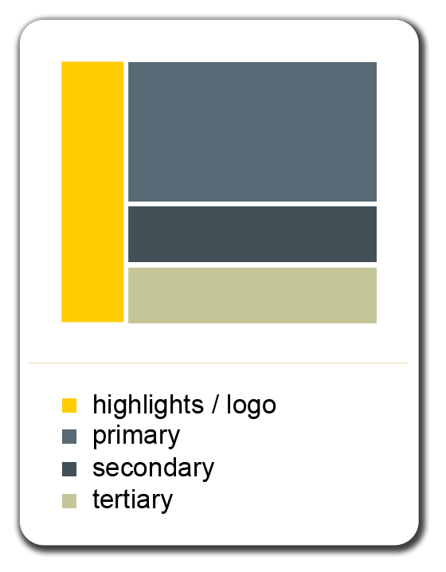
Colour
Figure 2.2: EBGE colour scheme
STFU has chosen a range of shades of blue for the majority of the site’s colour. The colour blue is proven to be extremely effective in promoting and advertising technological products (video gaming has its basis in modern technology) and provides a sleek, polished feel. Blue is also a “male colour;” most males can associate with and feel comfortable around it (Selling-it, 2002). As masculine as blue is, there is no indication in our research that it alienates females. STFU’s research indicates that the video game genres, especially first-person shooters, are very masculine elements, and that the blue will only enhance this masculine connection. More specifically, the shades of blue we have chosen are on the darker side; dark blues represent power and integrity, a feeling that we wish site visitors to experience.
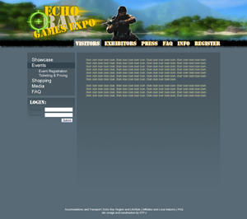
Figure 2.3: Colours come together
Two additional colours that make up the design are a light beige colour and a bright yellow/gold colour. The beige will be used primarily for the font colour and for glows around titles. The bright yellow/gold colour is to be used in the logo and highlights (such as borders around images). The logo will combine the yellow with other bright, hot colours to ignite the sense of action and intense energy. The contrast between the blues will also draw the eye to the logo to intensify these feelings.

Form and line
The design of the EGBE website follows a standard structure (See figure 2.4) A logo, header image and global navigation icons will be placed at the top of the screen (section 1). A consistent place for menus and links make up the left hand side (section 2). The most important content will be on the middle section of each page throughout the site (section 3). The bottom of all pages will contain another set of global navigation links (section 4). STFU has chosen this layout because it draws attention to and highlights the appropriate sections. The logo and website title will be positioned near the top left as research has shown that this is where the most reader attention is focused (Hamilton, 2006).

STFU will employ the use of solid rectangle and horizontal shapes in the design to create a sense of stability, balance, and precision (Hamilton, 2006). It conveys the message that The EBGEOC is focused and professional. Softer circles and rounded edges appear to create a sense on unification and completeness.
Section 1
Section 2
Section 3
Section 4
Figure 2.1: Site layout
Figure 2.4: Site layout

Site navigation and design diagrams

As a result of the client and user needs analysis STFU will use a layout which divides the site into clearly recognisable areas for each audience. The site will rely on textual navigation rather than images and logos.

The entrance to the site will be a general splash page. On the splash page will be a brief introduction to the Echo Bay Games Expo and a summary of the site content. The centre piece of the page will be three boxed areas. These areas will be the entrance points for each audience. They will be titled Visitors (mostly gamers, but also anyone else wishing to find out information about the expo), Exhibitors (both developers and hardware manufacturers/retailers) and Press (newspapers, magazines etc.).A login section will also appear under each.

There will be links to accommodation and transport, affiliates (writer’s festival) and local industry, as well as site registration and event timetable, floor plan and venue details. We have classed these pieces of information as universal; therefore we have not placed them into a particular audience area and they will be easily accessible from any page on the site.

When a user clicks on one of the three entrance points they are taken to the homepage for that audience. The content of the site will be constructed so that all the information relevant to each audience is available within these specific areas. Users shouldn’t need to navigate across the areas to find information; although they are free to do so assuming they have they are appropriately registered.

Site Map

Splash Page
(These pages will be accessible from anywhere on the site. They will form a global navigation bar at the bottom of every page.)
Site registration
Timetable, floor plan, and venue
Accommodation and transport
Echo Bay region and lifestyle
Affiliates and local industry
About us
Site map
Site FAQ
Visitor Homepage
Showcase
Games
Technology
Exhibitor list
Events
Event registration
Ticketing and pricing
Shopping
Vendor products
EBGE merchandise
Media
Game demos
Game reviews
Technology reviews
Screenshots/Wallpapers/Videos
FAQ
Exhibitor Homepage
Showcase
Games
Technology
Exhibitor list
Exhibitor registration
Costs
Events
Booths
Promotional and media relations
Content upload
Request information
FAQ
Press homepage
Showcase
Games
Technology
Exhibitor list
Media pass registration
Background
Request information
FAQ

Figure 3.1 on the following page is a diagrammatic representation of the site map and page relationships.
Visitors
Site registration
Echo bay region and lifestyle
Accommodation and transport
Timetable, floor plan, and venue
Affiliates and local industry
Site FAQ
About us
Exhibitors
N.B. These pages are not connected only to the splash page. They will be accessible from every page on the site via navigation links on the bottom of every page.
Showcase
Exhibitor registration
Promotional and media relations
Splash page
Shopping
Media
Events
Request information
Event registration
Ticketing and pricing guidelines
Vendor products
EGBE merchandise
Shopping cart
Game demos
Game reviews
Technology reviews
Screenshot Wallpapers Videos
Background
Request information
Costs
Events
Booths
Content upload
Media pass registration
Exhibitor information
Press
Games
Technology
Exhibitor list
Site Map
Figure 3.1: Site map
Accommodation and Transport
Timetable, Floor Plan, and Venue

Site Registration
Site FAQ
Echo Bay Region and Lifestyle
Affiliates and Local Industry
Event Registration
Ticketing and Pricing Guidelines
C
A
R
T
Game Demos
Technology
Reviews

Game Reviews

Screenshots Wallpapers
Videos

Exhibitors Homepage

- Latest News and Information
- Login

Visitors Homepage

- Latest News and Information
- Login

Splash Page

- Introduction
- Overview
- General Expo News
- Login

Press Homepage

- Latest News and Information
- Login

% Exhibitor Registration
Showcase
Technology

Games

Exhibitor Guidelines
% Promotional and Media Relations
% Request Information
Content Upload
FAQ
FAQ
Media Pass Registration
Background
% Exhibitor Information
FAQ
Legend
Show the how users may navigate through the site.

% Means that the content is locked and can only be viewed by a registered member of that audience (i.e. an exhibitor).

Red boxes indicate that the page is accessible from everywhere; these pages will have separate global navigation links at the bottom of every page.
Shopping
Media
Events
Exhibitor List
Exhibitors will get a more detailed version of this.
Events

Booths

Costs

% Request Information
Legend
The way we have designed our navigation structure means that every page under the one audience (i.e. visitors) is accessible from any page within that audience’s section. Boxes of the same colour show this relationship (i.e. they are all accessible from any page within that section).

About us
Vendor Products
EBGE Merchandise
Storyboard
Figure 3.2: Storyboard
Figure 3.3 is an example of how the navigation will work. In this case the user is on the Exhibitor’s homepage; these are the navigation options they will see down the left hand side of the page. These will appear on every page in the exhibitors section.
Showcase
Games
Technology
Exhibitor list

Exhibitor Registration
Event registration
Ticketing and pricing

Shopping
Vendor products
EBGE merchandise
Media
Technology reviews
Game reviews
Screenshots/wallpapers
FAQ

REST OF THE PAGE CONTENT
Figure 3.3: Navigation layout

Paper Prototype

Webpage design templates

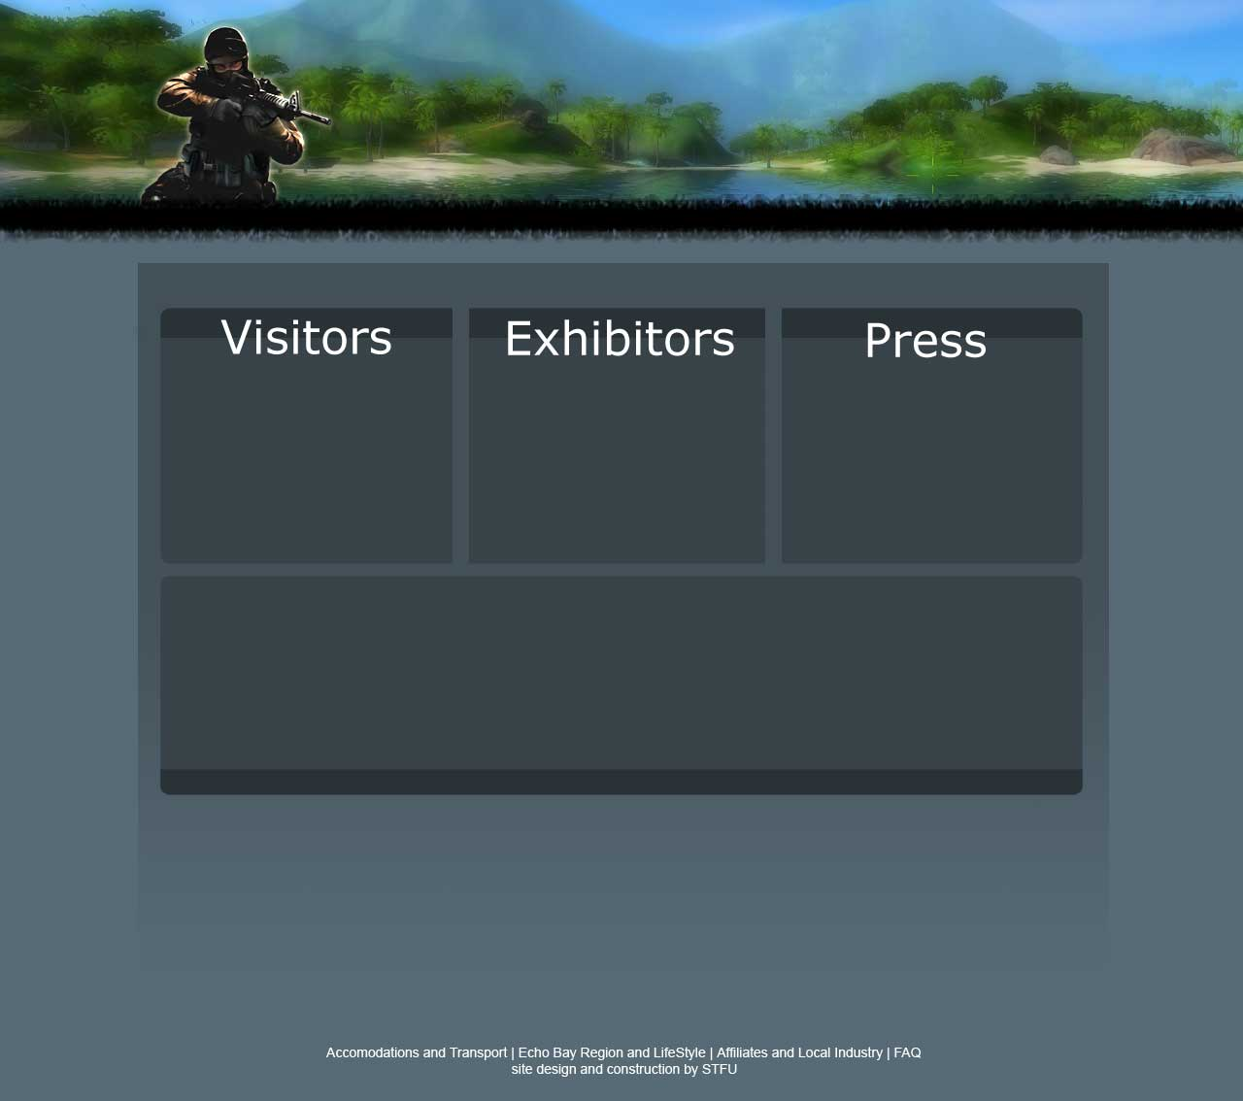

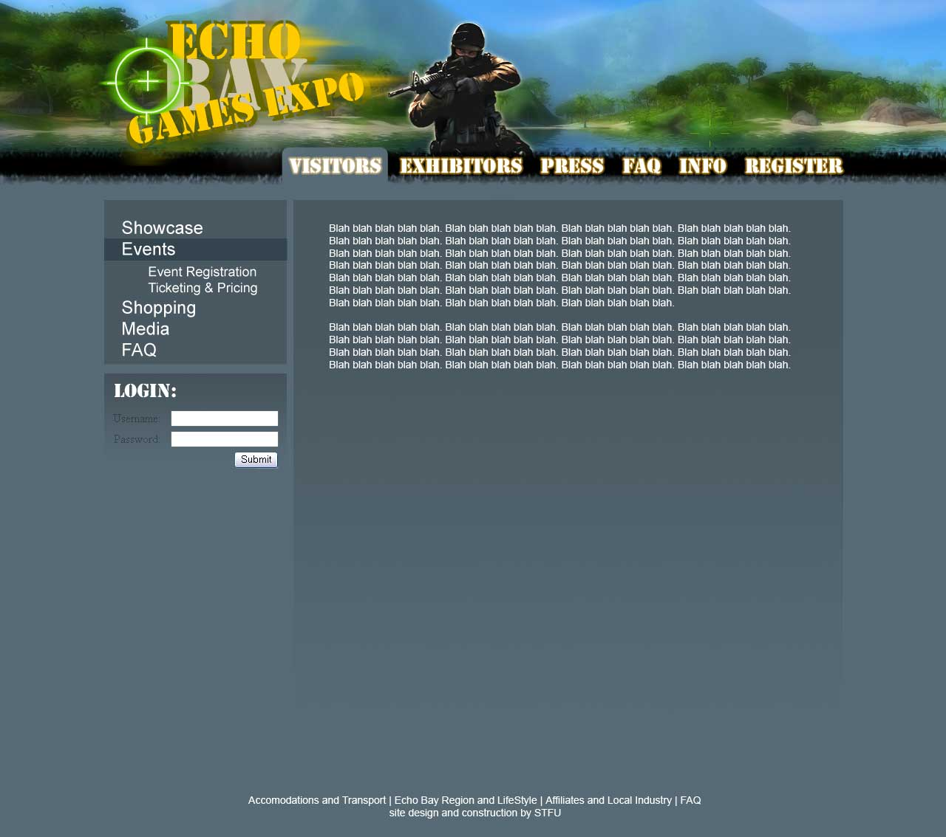

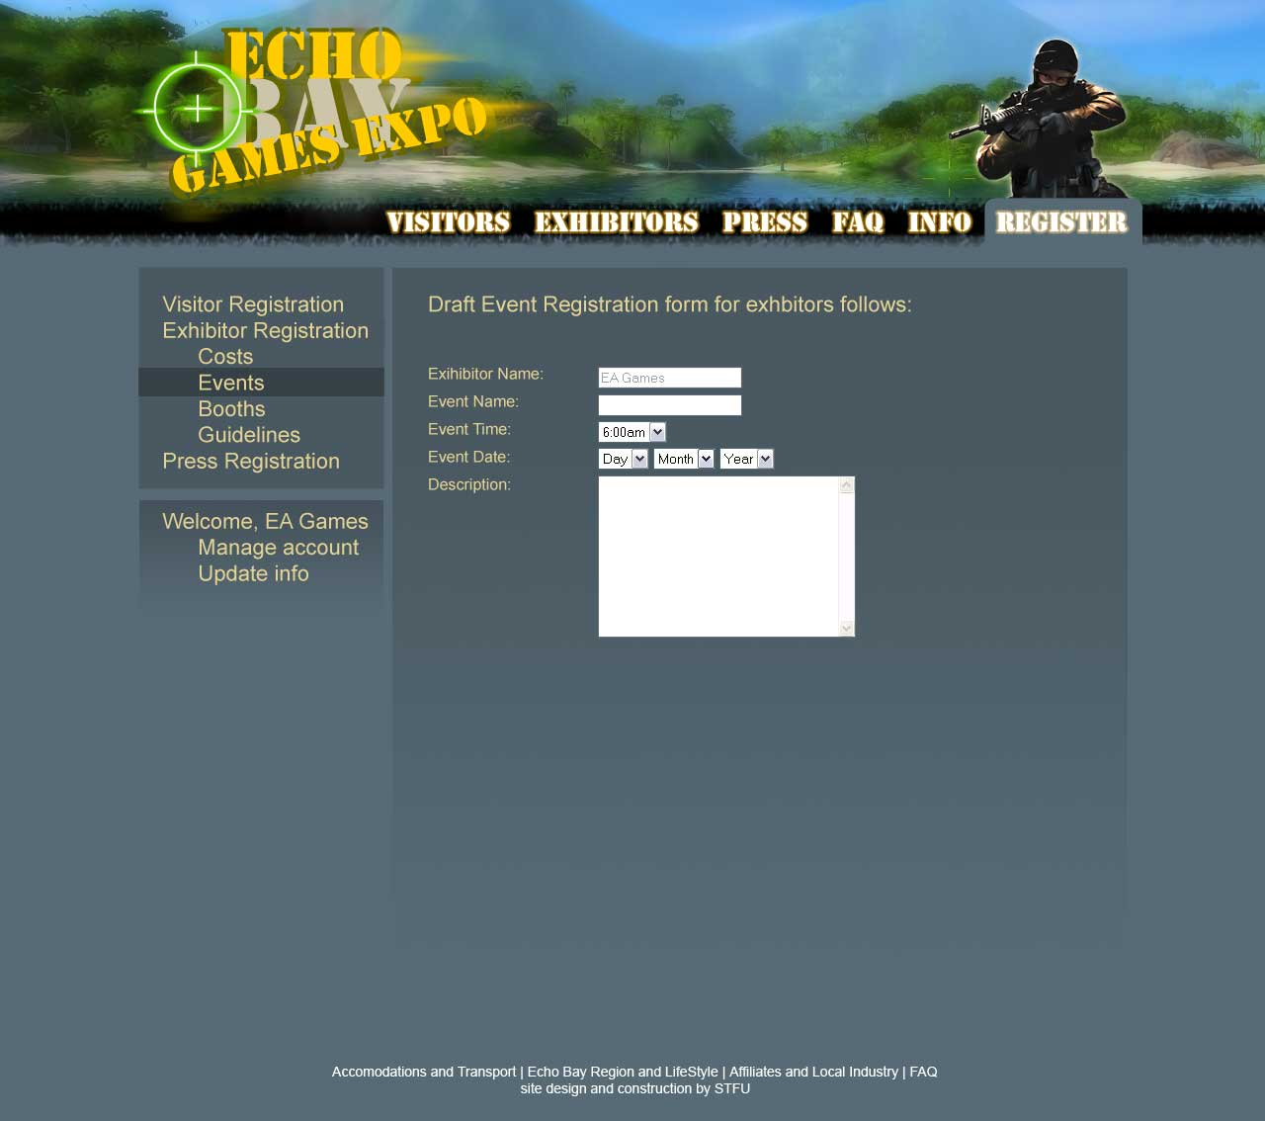

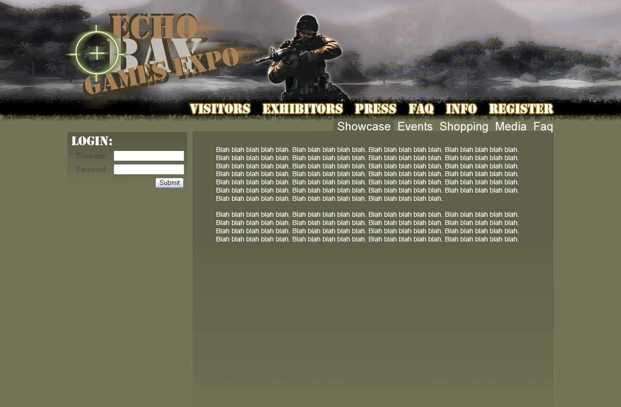

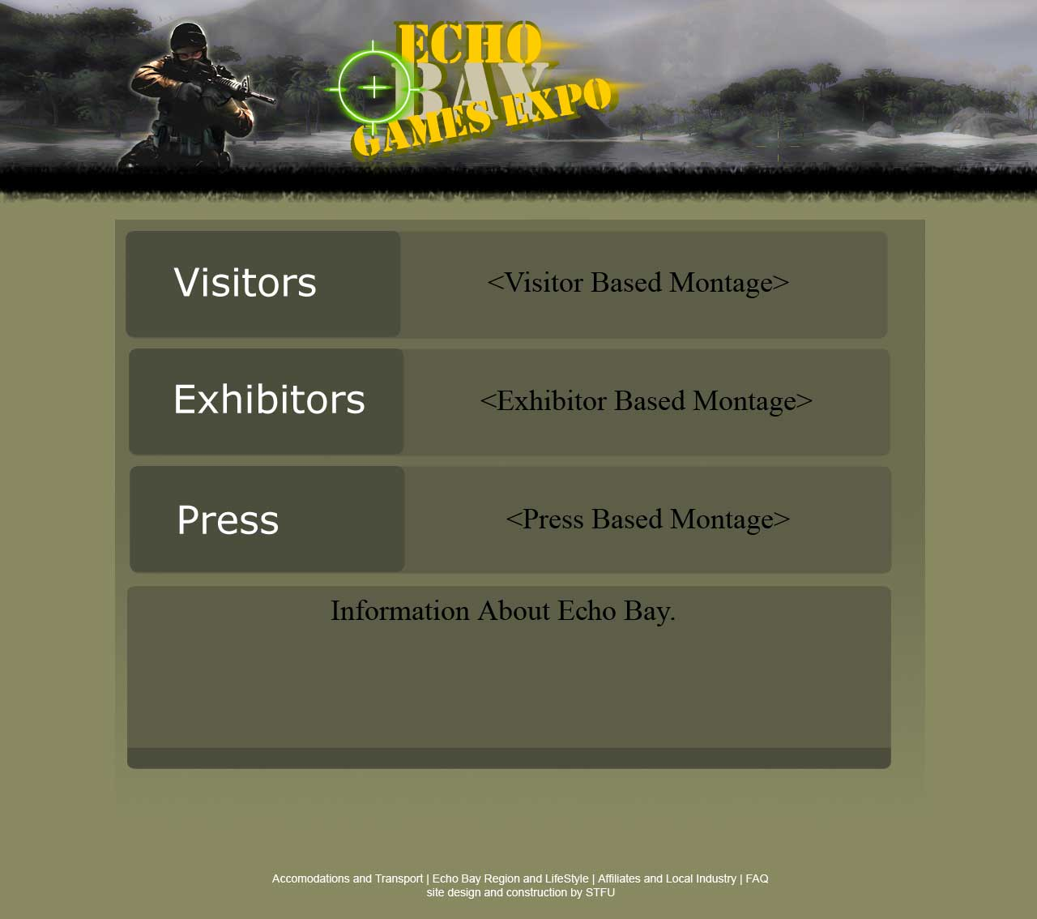

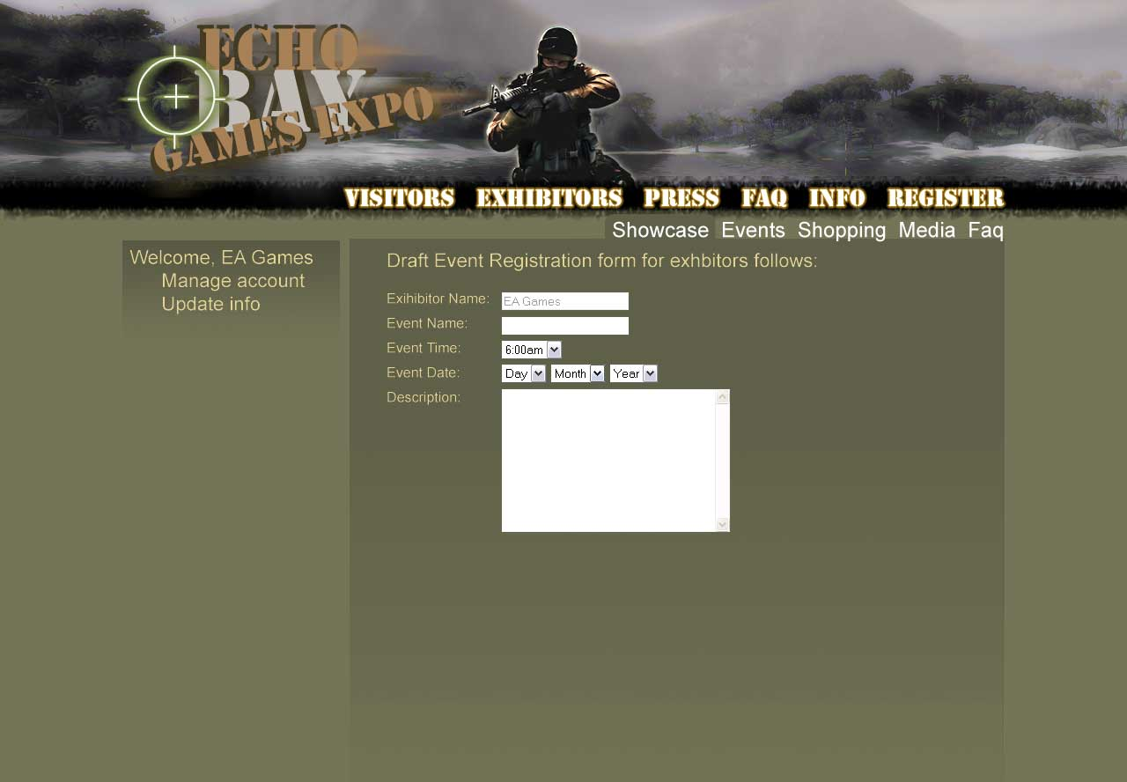

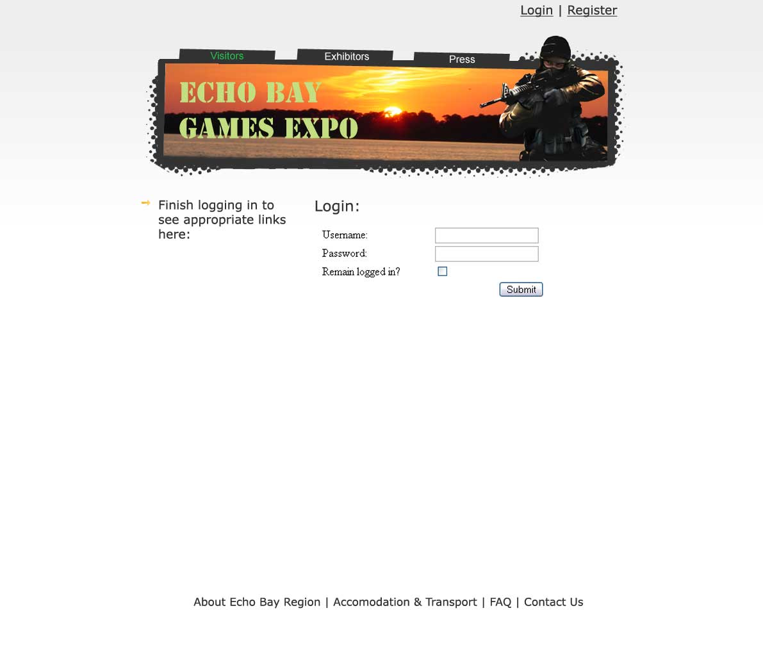

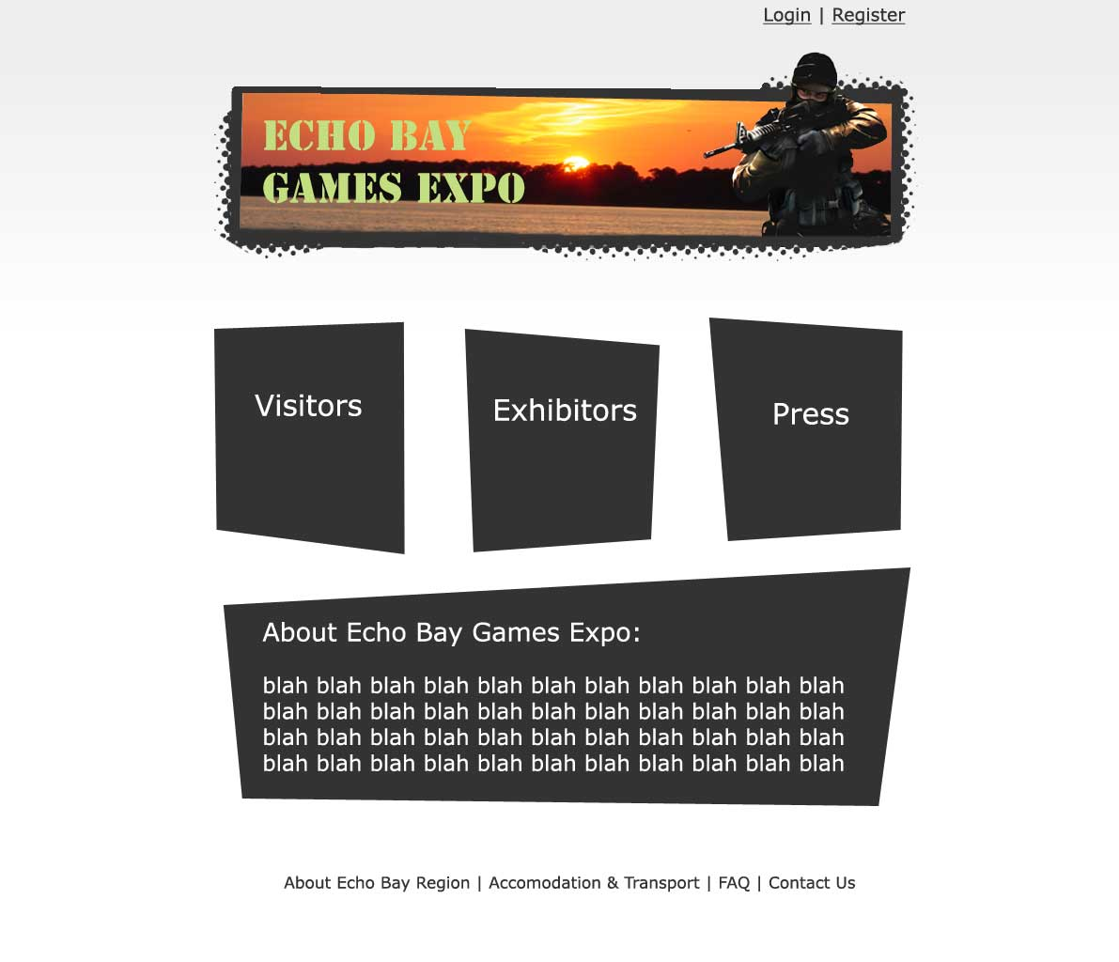

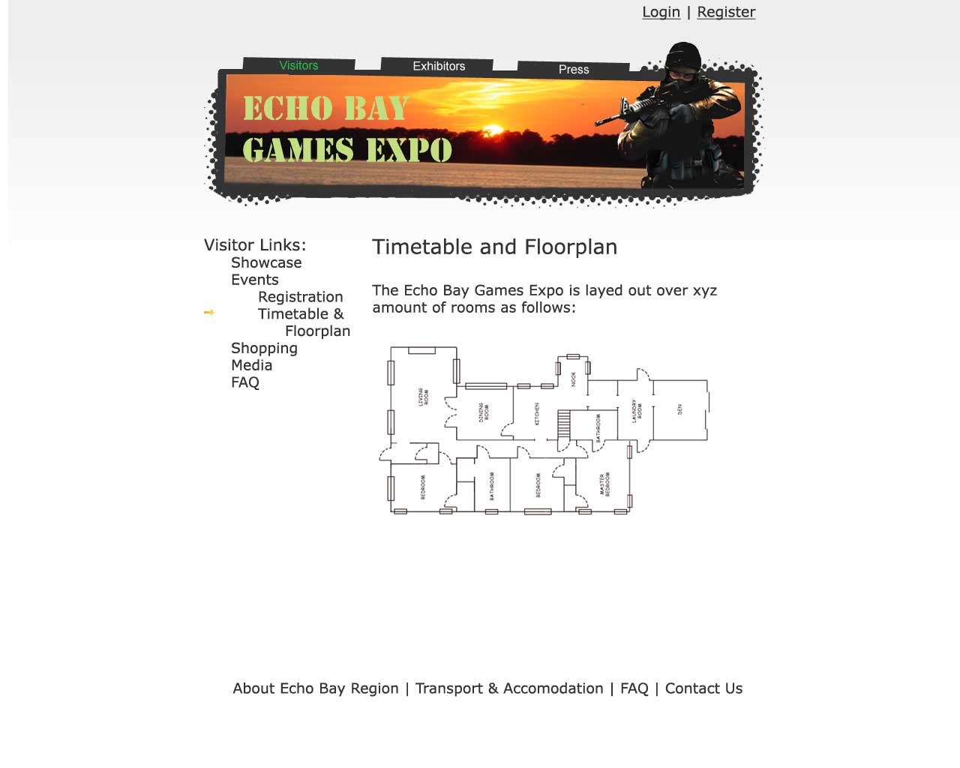

Conclusion

This report has detailed the design established by STFU based on the findings of the client and user needs analysis.

The establishment of three key audiences has lead to the design of a site with three distinct pathways. The site follows a conventional layout: with an image header and navigation icons at the top of the page; more navigation in an area on the left; the main site content in the middle; and, global navigation links on the bottom. STFU decided to incorporate shades of blue as the site’s primary colour. Beige Verdana font will be used for the main text and Georgia for quotes and printer formatted text. For contrast a bright gold/yellow colour scheme was employed for logos and borders.

These design decisions have addressed the key objectives of the site as recommended by the client and user needs analysis and provides a way to deliver content which fulfils the requirements for information delivery, sales and merchandising, and promotional material.

STFU believes its meticulous attention to detail and thorough analysis of client needs has led to a dynamic, creative and innovative design that will create a successful web presence for the EBGE and its community.

References

Andrew Hume, (2005). The anatomy of web fonts. Retrieved May 19, 2006, from http://www.sitepoint.com/article/anatomy-web-fonts

Dirk Knemeyer, (2005). Design eye for the ideas guy. Retrieved May 16, 2006, from http://designeye.org/ideaguy/

Jillian Hamilton, (2006). ITB002 IT Professional Studies: Lecture 8. Brisbane: Queensland University of Technology.

Mario Sanchez, (2003). Web safe fonts for your site. Retrieved May 18, 2006, from http://www.theinternetdigest.net/archive/websafefonts.html

Michael Bloch, (2006). Psychology of colour. Retrieved May 21, 2006, from http://www.tamingthebeast.net/articles/colour.htm

Microsoft, (1997). Channel Verdana. Retrieved May 18, 2006, from http://www.microsoft.com/typography/web/fonts/verdana/default.htm

Selling-it.com, (2002). Website useability – Colour Meanings. Retrieved May 20, 2006, from http://www.selling-it.com/Useability/Color/Use_Color_Meanings.htm

WebsiteTips.com, (2006). Colour. Retrieved May 20, 2006, from http://websitetips.com/color/

Appendices

Contributions of Each Team Member

Team Members’ Contributions to this Report
 |  | Lachlan George | Bodaniel Jeanes | Ross Brackstone |  | Total
PROCESS Indicate each team member’s relative contribution in the cells below. A worked example is provided.
Planning |  |  |  |  |  | 100
Development & Drafting |  |  |  |  |  | 100
Editing & Integration |  |  |  |  |  | 100
Final Print, Bind & Submit |  |  |  |  |  | 100
PROCESS SUB-TOTAL |  |  |  |  |  | 400
CONTENTS Indicate each team member’s relative contribution in the cells below. A worked example is provided.
Executive Summary |  |  |  |  |  | 100
Introduction |  |  |  |  |  | 100
Description of Web Site Design Considerations |  |  |  |  |  | 100
Site and Navigation Design Diagrams |  |  |  |  |  | 100
Web Page Design Templates |  |  |  |  |  | 100
Conclusion |  |  |  |  |  | 100
Original/ Innovative Material |  |  |  |  |  | 100
CONTENTS SUB-TOTAL |  |  |  |  |  | 800
INDIVIDUAL TOTAL |  |  |  |  |  | 1200

